**Chef Compliance Server Setup**

1. To install chef server follow the document provided in the link :

<https://docs.chef.io/install_compliance.html>

1. Once the chef-compliance server is configured set its FQDN name:

[URL:<fqdn>/#/setup](URL:%3cfqdn%3e/#/setup)

You can set your username and password and click on Configure button.

Your chef-compliance sever is configured now!

**Use Inspec to start writing your Profiles and uploading them on the Server GUI**

**(Download and Install Inspec in your chef-compliance server)**

**Link :** [**https://www.chef.io/inspec/**](https://www.chef.io/inspec/)

1. Create your profile :

**$Inspec init profile <profile_name>**

You will get your profile created with the directory structure as :

<Profile_name>

* Controls
  + Example.rb //you write your profile code here
* Inspce.yml
* Libraries
* README.md

1. Check your profile with the command:

**$Inspec check <profile_name>**

1. Execute your profile with the command :

**$Inspec exec <profile_name>**

1. Upload your profile :

(Note : Before uploading make a connection to your chef-compliance server GUI using the command :

**$inspec compliance login https://<Serverip/fqdn> --insecure --user <username> --token ‘<token’>**

***)***

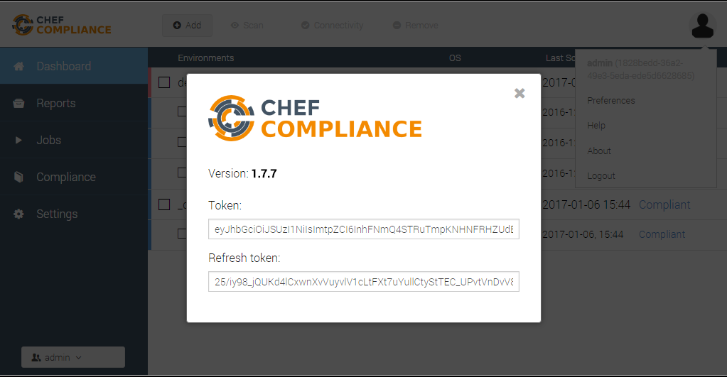

(Note: You get this token from chef-compliance server GUI

Go to **Dashboard**>>Click on the right hand corner(**User**)>>**About)**

Once you are connected to your server, Upload your profile using command :

**$inspec compliance upload <profile_path>**

1. This is how your chef-compliance server will look:

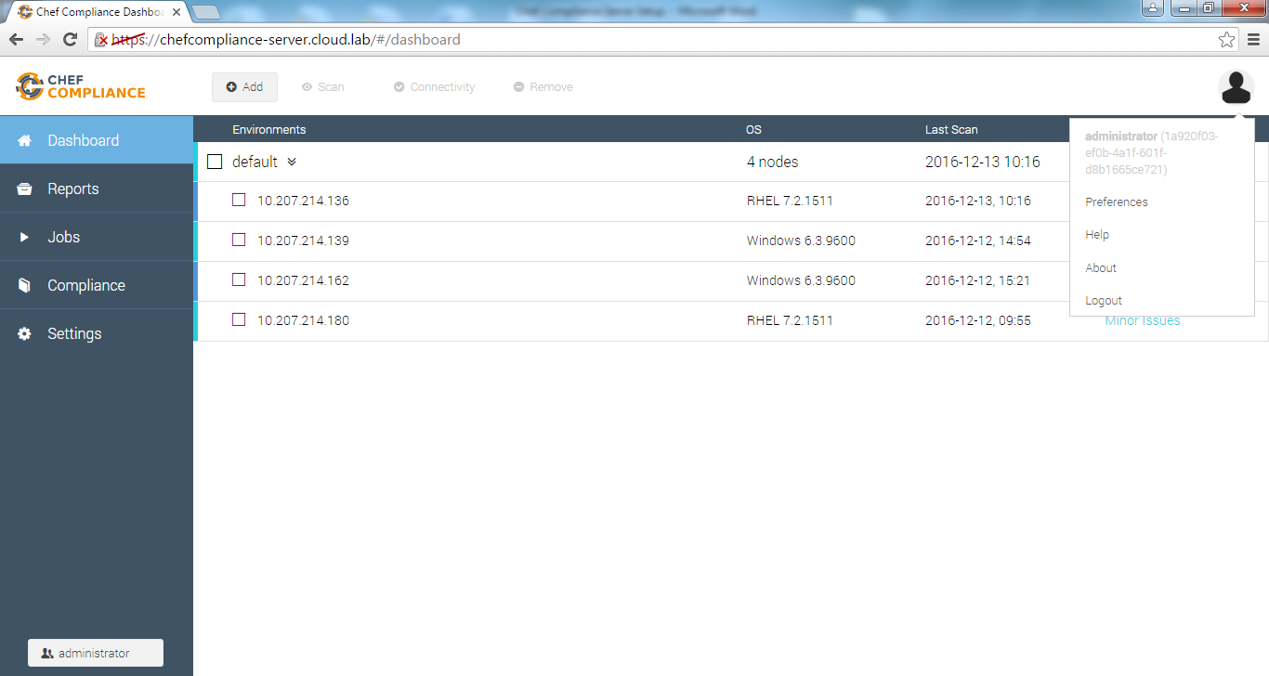

1. On **Dashboard**, click on **Add** to add a node to your server.

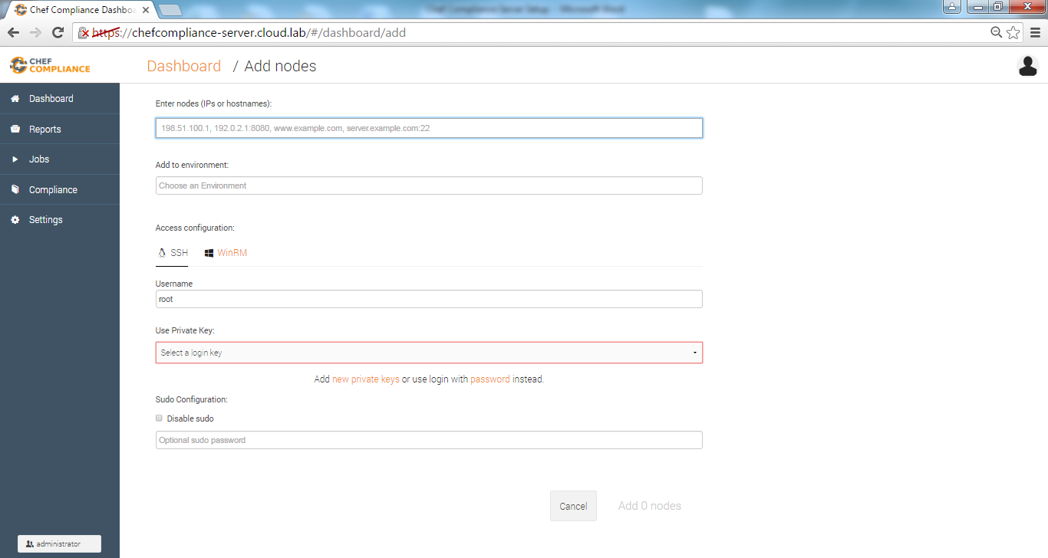

* Provide **Ipaddress**
* Select **Access** **Configuration** and provide **Username** and **Password**
* Click on **Add node**
* Your node will be successfully added.

1. Test your node with profile.

Select a node you want to test and click on Scan button

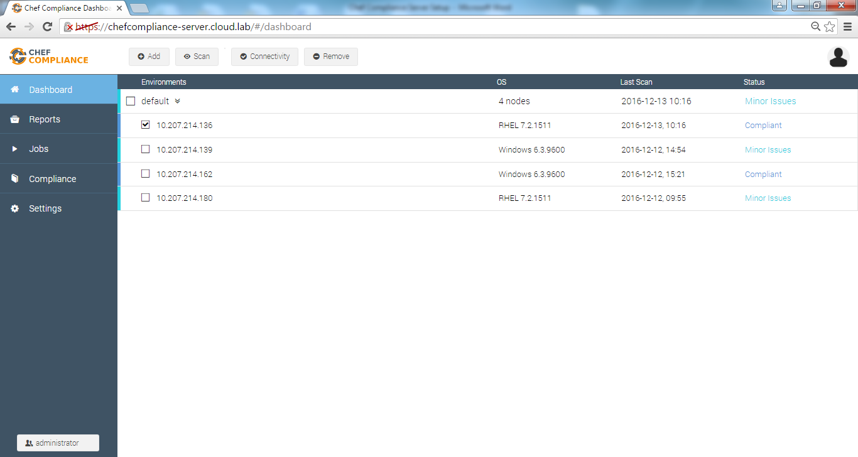

1. Select the profile you want to test your node with.

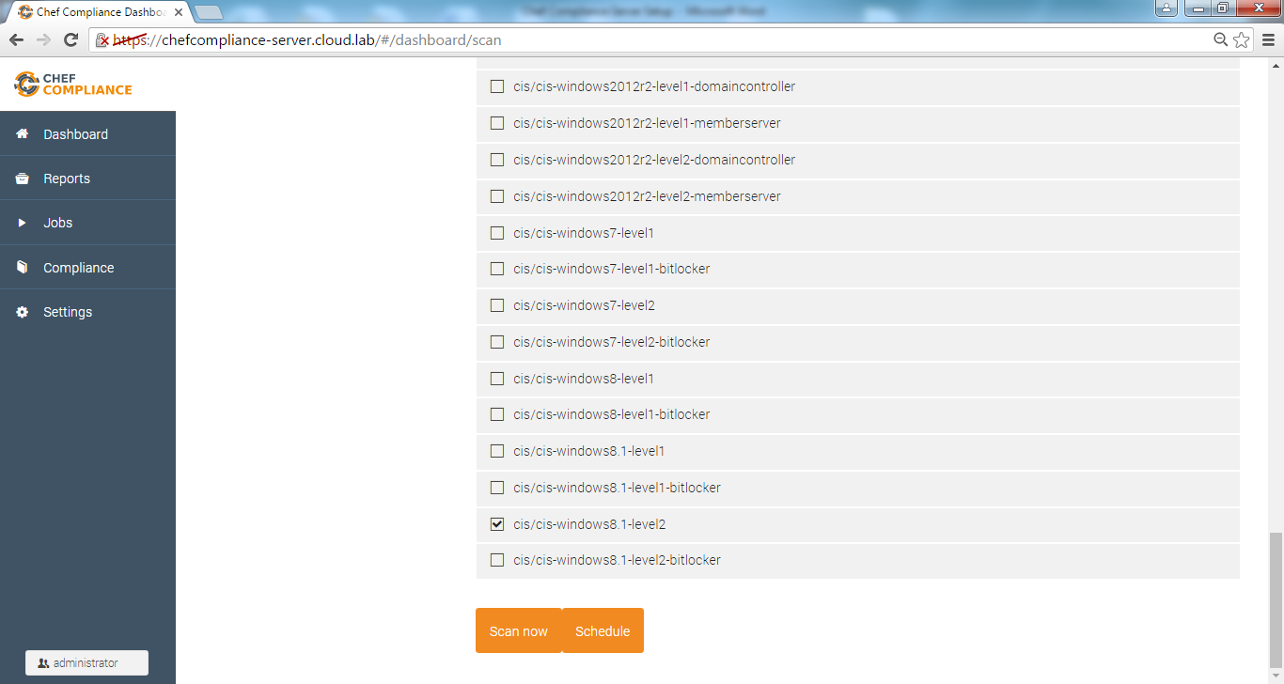

Click on **Scan** **now** or **Schedule** a scan later.

1. Check the results

